**Designing an AWS Three-Tier Architecture**

This architecture consists of three layers: the Web Server Tier, the Application Tier, and the MySQL RDS Database Tier. The Multi-Tier Architecture is highly favored and widely adopted in cloud computing due to its long-standing presence and its suitability for developing user-friendly applications. According to AWS, the three-tiered architecture comprises three layers: the Presentation Tier, the Application Tier, and the Data Tier.

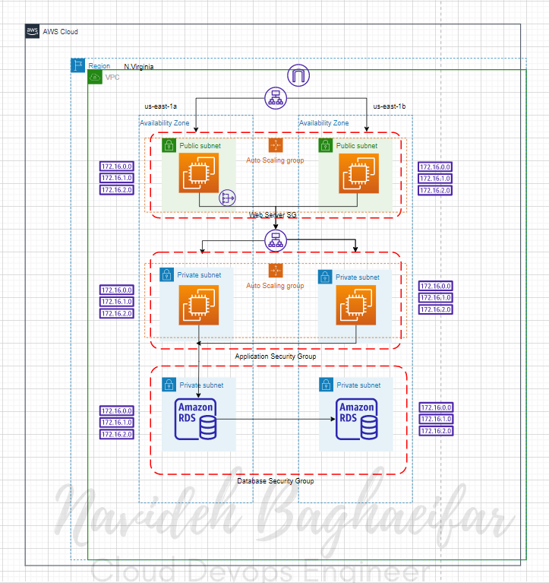

The Presentation Tier serves as the user interface, enabling individuals to interact with the application. Typically designed for personal computers or mobile devices, it is constructed using HTML

The Application Tier, also known as the logic tier, resides between the presentation tier and the database tier, facilitating communication between the two. It plays a crucial role in processing the information and requests collected from the web tier. Additionally, it interacts with the database where data is stored.

The Application Tier comprises code that translates end user actions into application functionality, including database operations and processing such as Create, Read, Update, and Delete (CRUD) operations.

The Database Tier is responsible for storing and processing data, typically utilizing a database management system. It serves as the component that handles data storage and retrieval operations.

Web Tier

2 public subnets

Minimum of 2 EC2 instances with an OS of your choice (free tier) in an Auto Scaling Group.

EC2 Web Server Security Group allowing inbound permission from the internet.

Create a public route table and associate the 2 public subnets.

Application Tier

2 private subnets

Minimum of 2 EC2 instances with an OS of your choice (free tier) in an Auto Scaling Group.

EC2 Application Server Security Group allowing inbound permission from the Web Server Security Group.

Associate with private route table.

Database Tier

Use a free Tier MySql RDS Database.

The Database Security Group should allow inbound traffic for MySQL from the Application Server Security Group.

2 private subnets.

Considerations:

You will need to configure a public route table along with private route tables.

You will need a Nat Gateway in one of your public subnets to allow your instances in private subnets to update packages and patches. Make sure to include this in the private route table.

In order to reach your EC2 instances in the private subnets, you will need to use SSM.

Plan out your CIDRs before you create your VPC and Subnets

**Step 1: Create our VPC and Subnets**

Upon reviewing our architecture diagram, it is evident that we require the creation of 1 VPC, 2 public subnets, and 4 private subnets. To proceed with this setups.First Navigate to the VPC resource,then Click on “Create VPC.”

IPv4 CIDR block: 10.0.0.0/16

Tenancy: Default

Availability zones: 2

Number of public subnets: 2

Number of private subnets: 4

Internet gateway: Attached to our VPC

Route Tables: 2

NAT gateways: 1

VPC endpoints: None

Enable DNS hostnames: yes

Enable DNS resolutions:yes

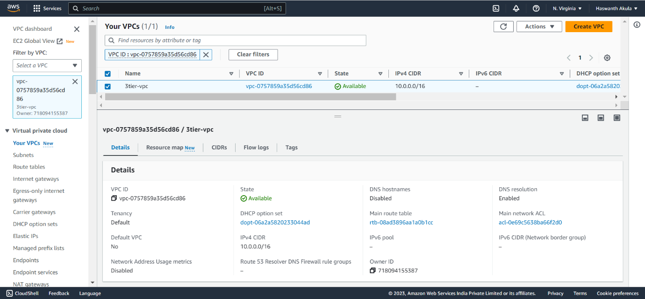

Creation of all 6 subnets, navigate to the “Subnets”

Public Subnets: 2 (WebTier)

Private Subnets: 2 (AppTier)

Private Subnets: 2 (DataBaseTier)

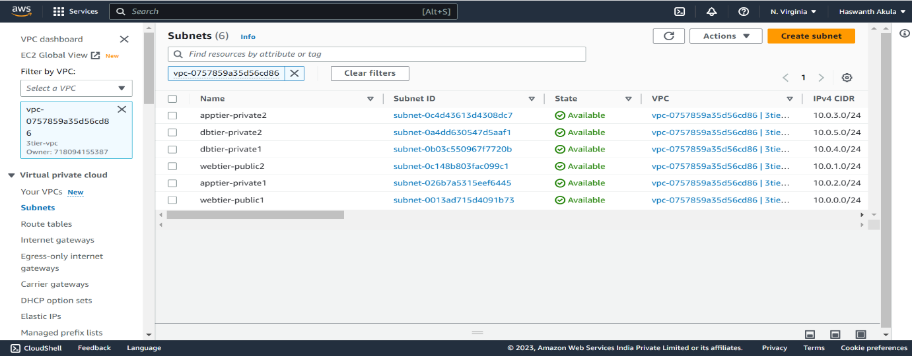

we need to configure each public subnet individually to enable the auto-assignment of public IPv4 addresses. Follow the steps below:

Select one of the public subnets from the list.

Click on the “Actions” button located at the top right corner of the page.

From the dropdown menu, choose “Edit subnet settings”.

Select “Enable auto-assign public IPV4 address”, the click “Save”.

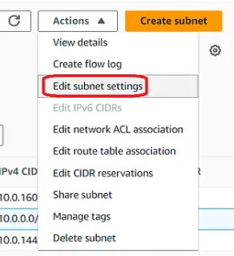

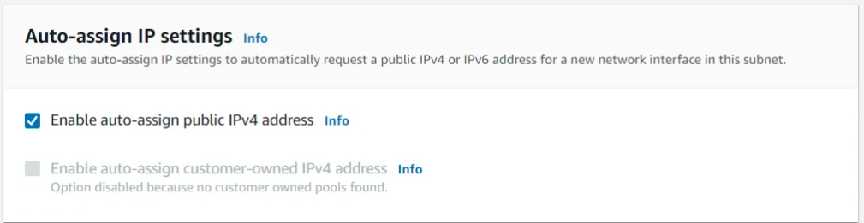

Creating Internet Gateway & Attach to VPC

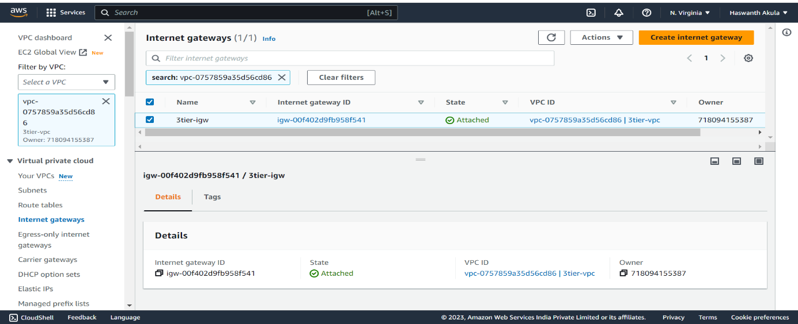

Creating NAT Gateway

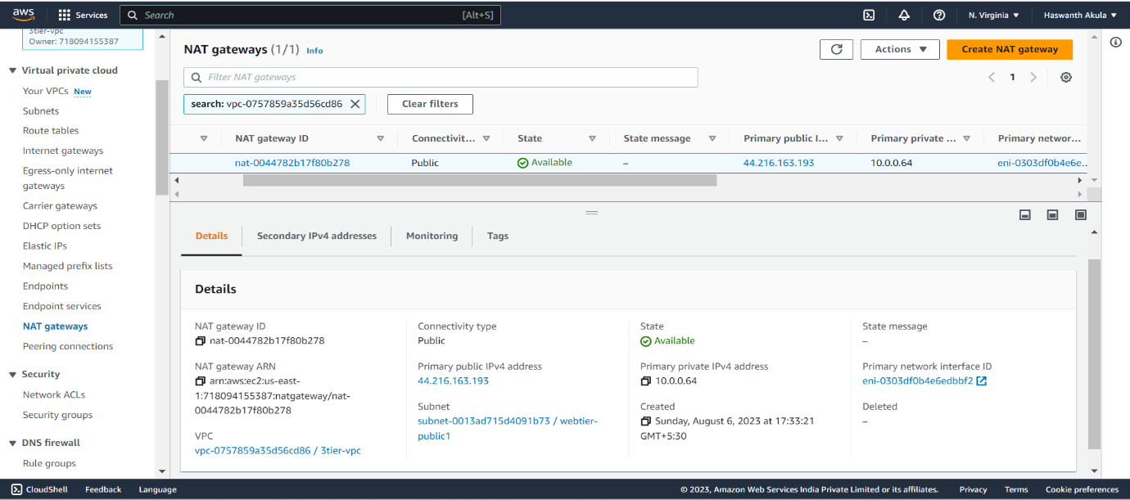

Creating RouteTables:

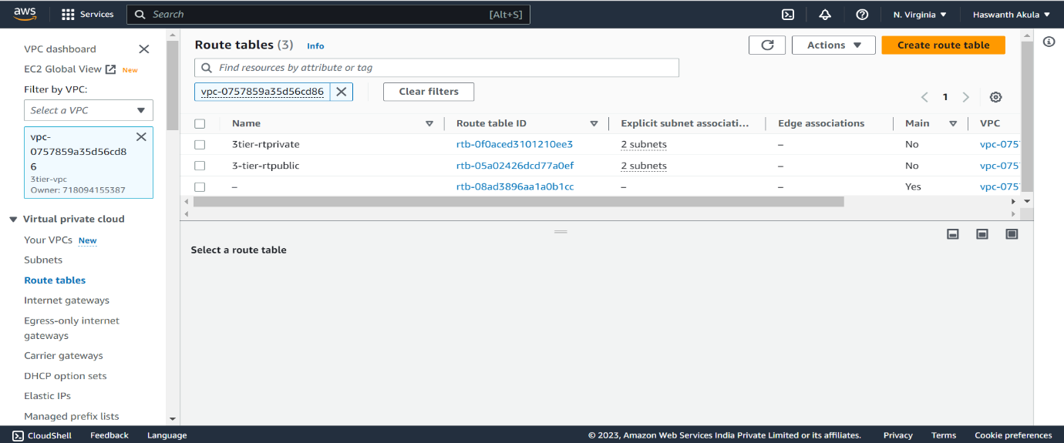

Public RouteTable: Attach Internet Gateway and Associates WebTier Public Subnets.

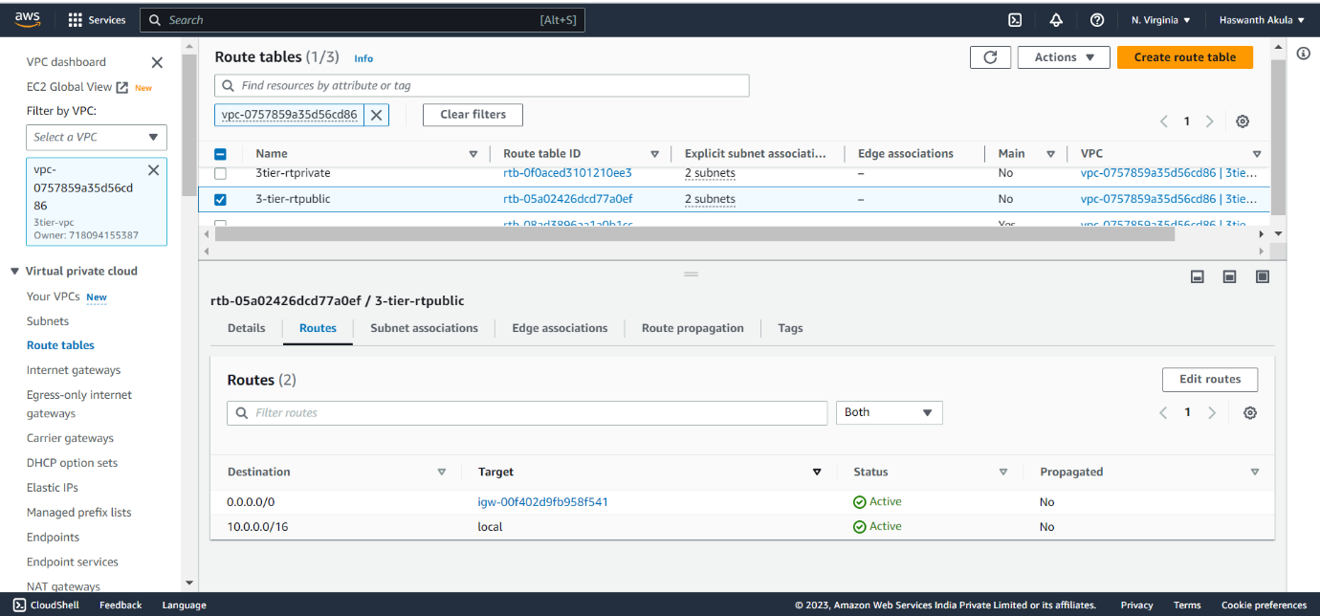

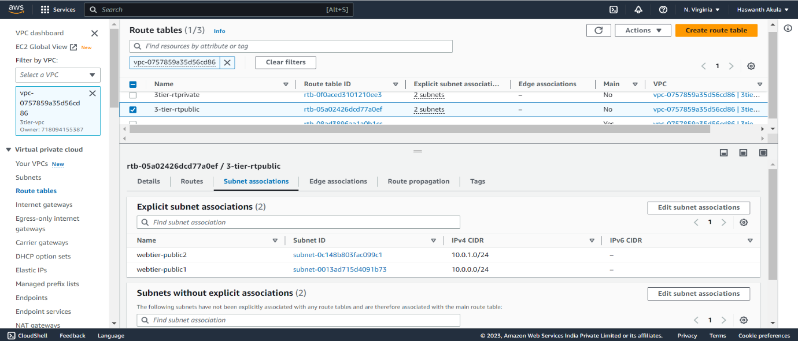

Private RouteTable: Attach NAT Gateway and Associates AppTier Private Subnets.

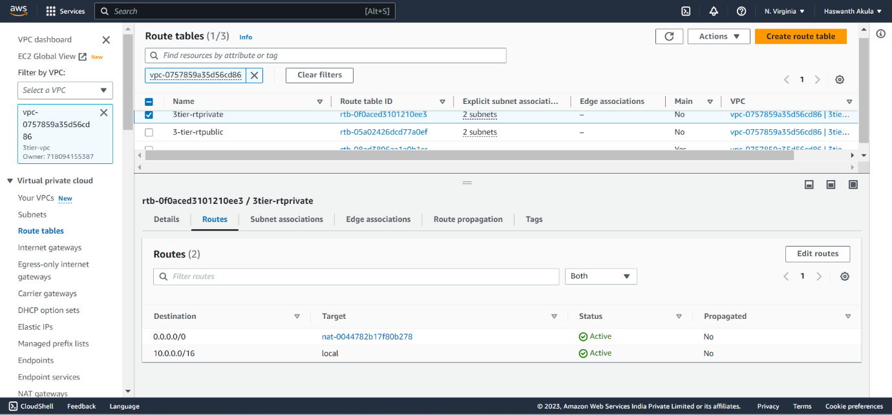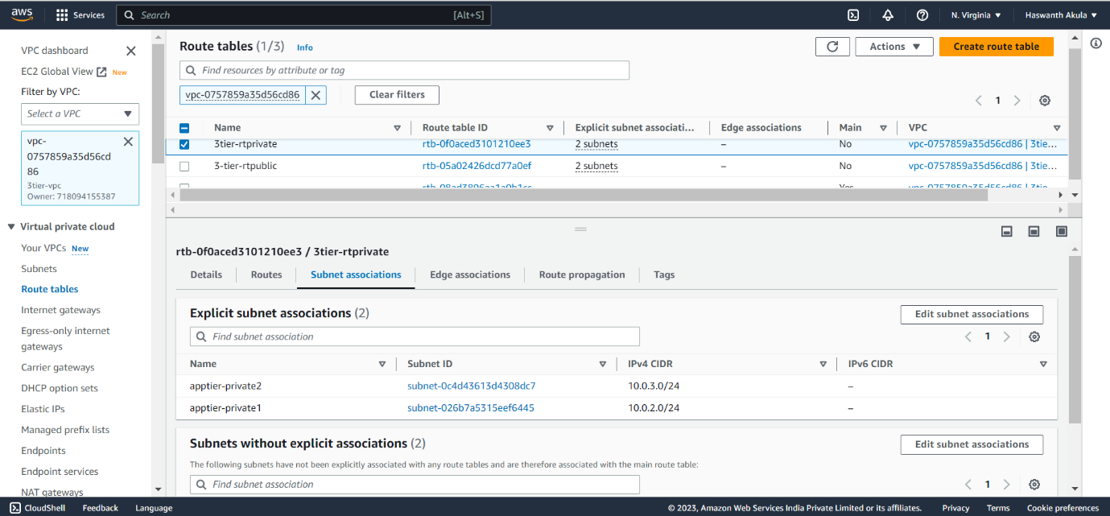

Overall the Networking Part of VPC looks like:

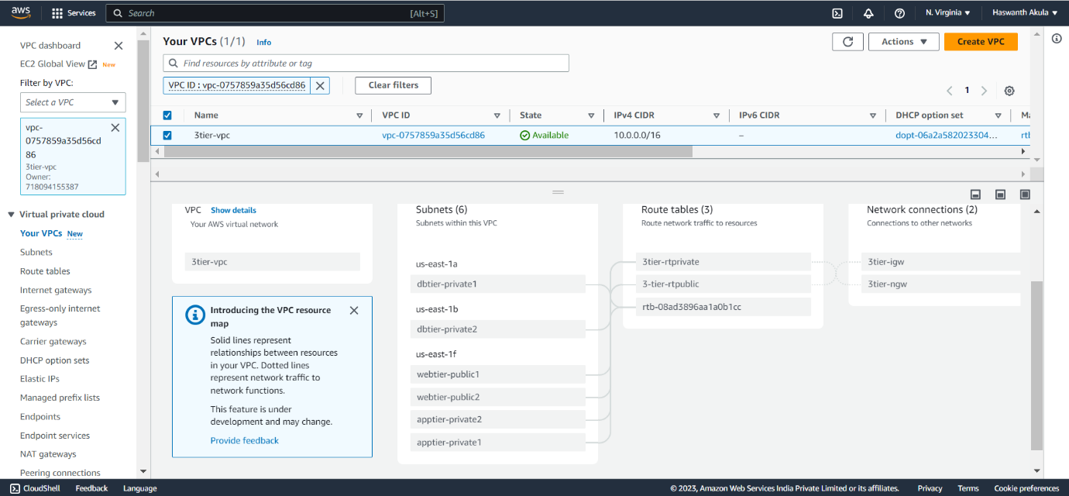

Step 2: Creating a Web Server Tier

We will create the first tier, which represents our front-end user interface. To accomplish this, we will create an Auto Scaling Group of EC2 instances that will host a custom webpage for us.

Navigate to your EC2 dashboard,on the left side, click “Auto Scaling Groups”, then “Create Auto Scaling group”

Give Name for your ASG, then click “Create a launch template”.

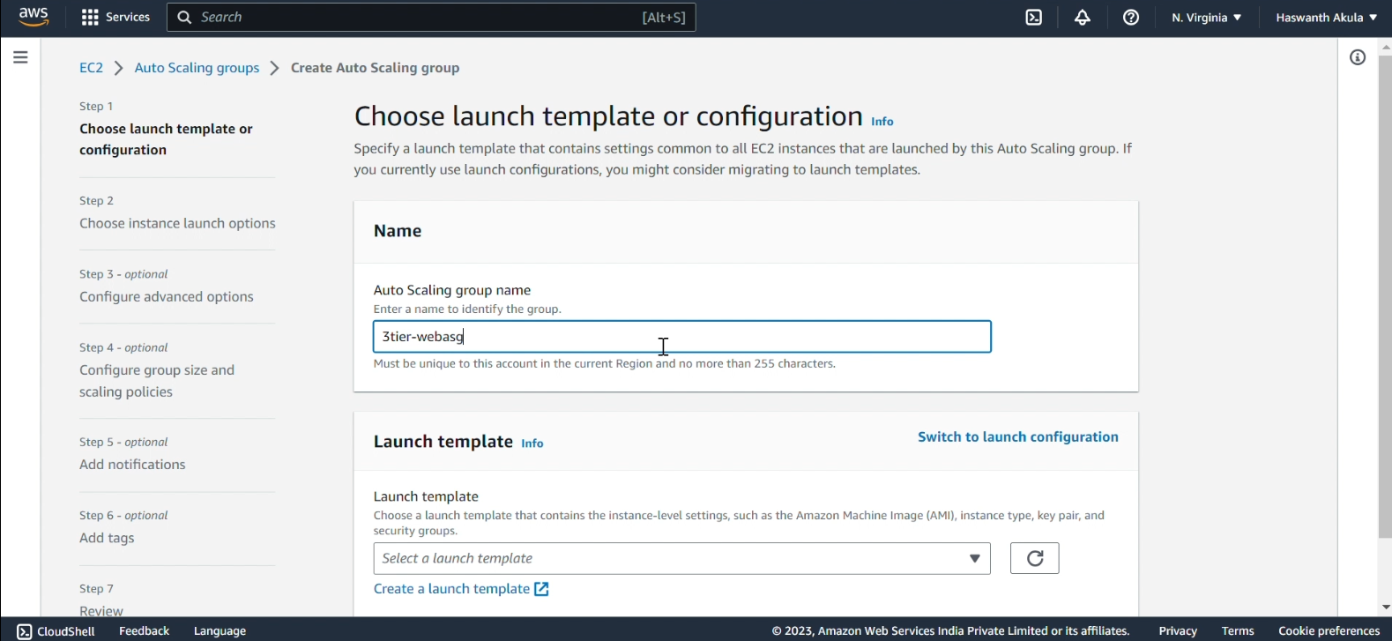

Once the launch template windows is opened, we will going to create a launch template with name and in Launch template contents we select our OS machine image.

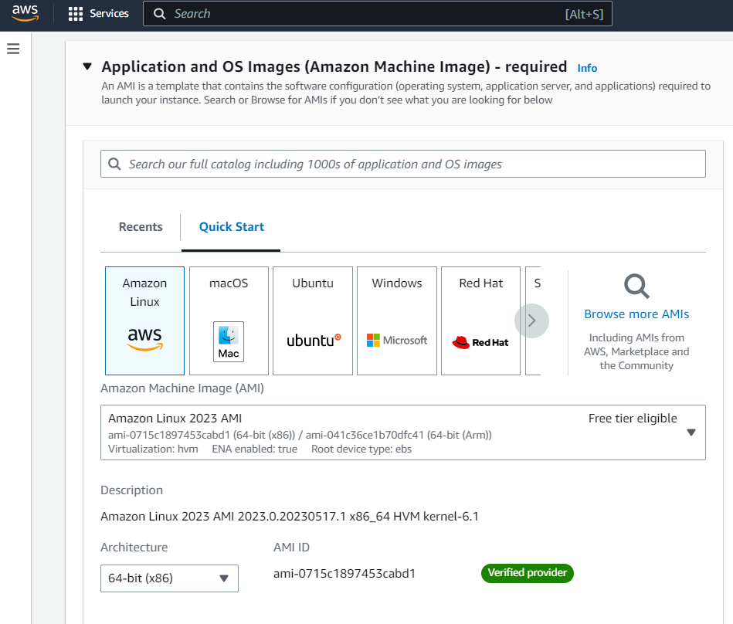

Select t2.mirco for our instance type then choose an existing key pair or creating a new a key pair.

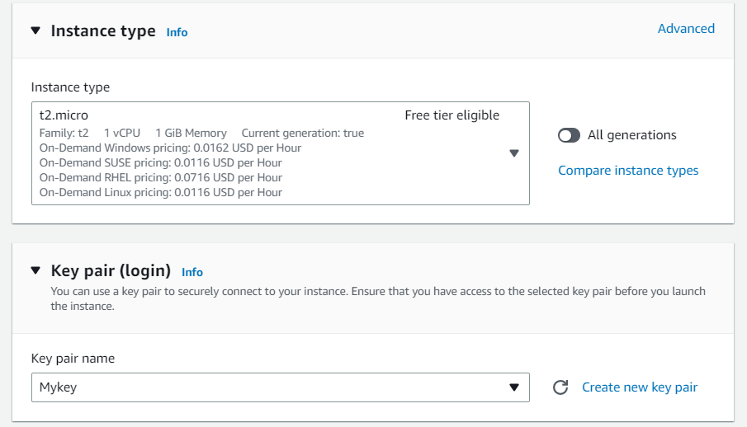

Continue by creating a new Security Group. Name your security group and make sure to select your previously created VPC.

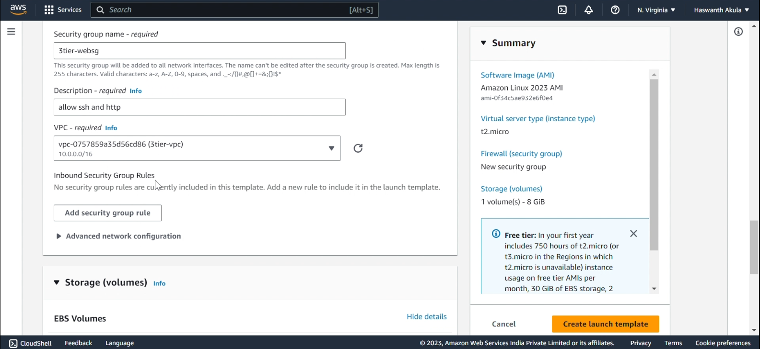

Under the Inbound security group rules we add HTTP(port 80) and SSH (port 22) access to our public facing EC2 Instances from anywhere.

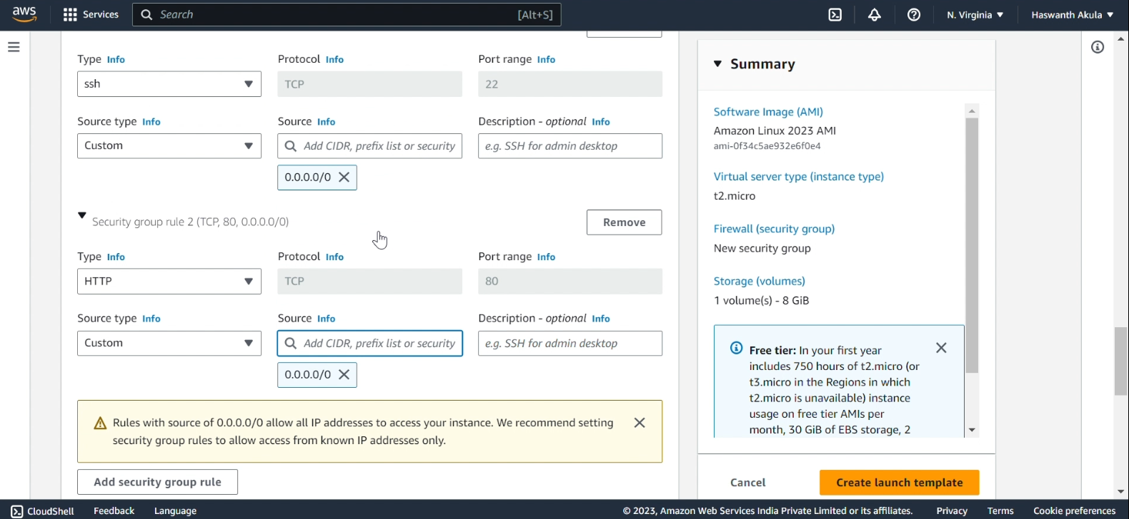

We will keep the remaining options as default and navigate to the “Advanced details” section. Scroll down and paste the following script in the “User data” field, then click “Create launch template”.

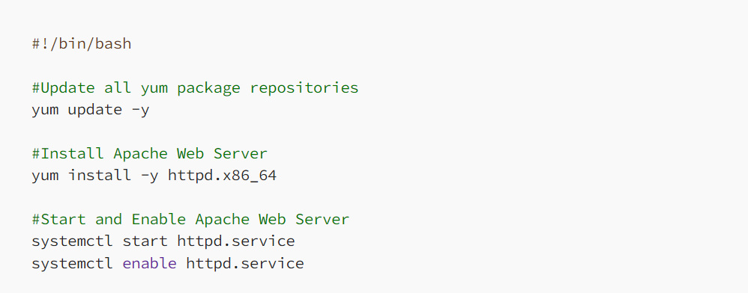

Once you have successfully created the launch template, return to the Auto Scaling Group (ASG) window. Choose the recently created launch template and proceed by clicking on “Next”.

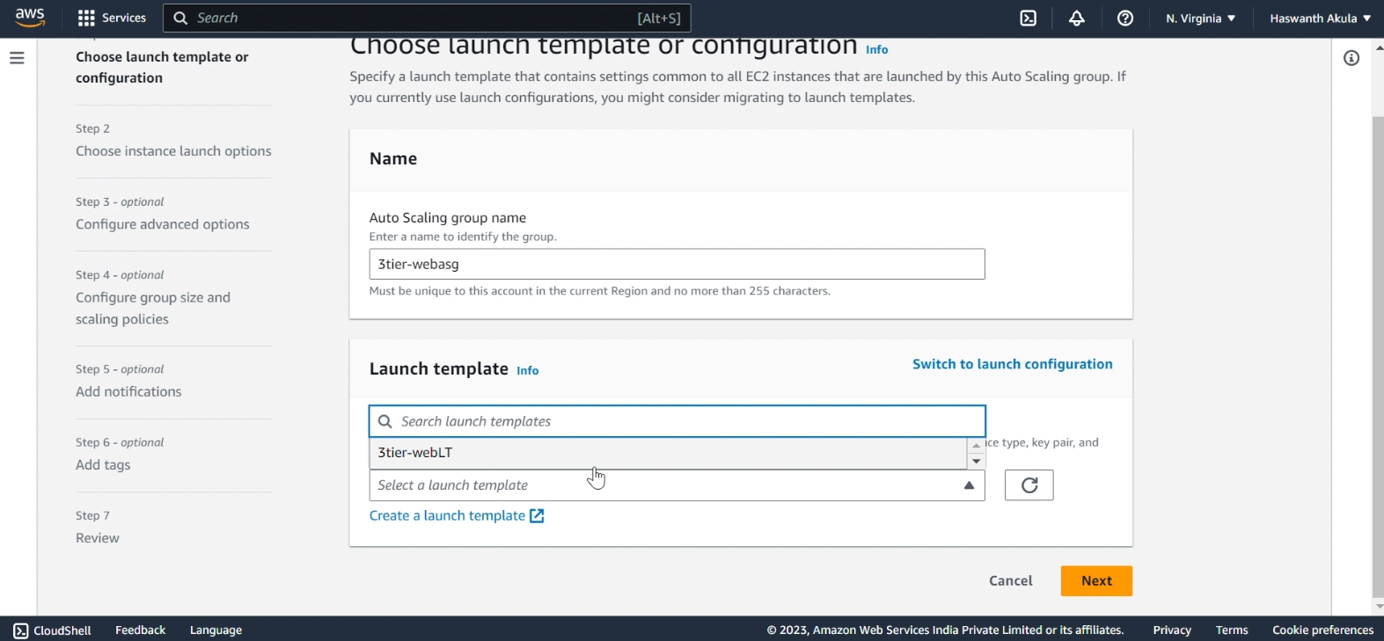

In the “Network” settings, opt for your Virtual Private Cloud (VPC) and select the two public Availability Zones (AZs) within your network. Afterward, click on “Next”.

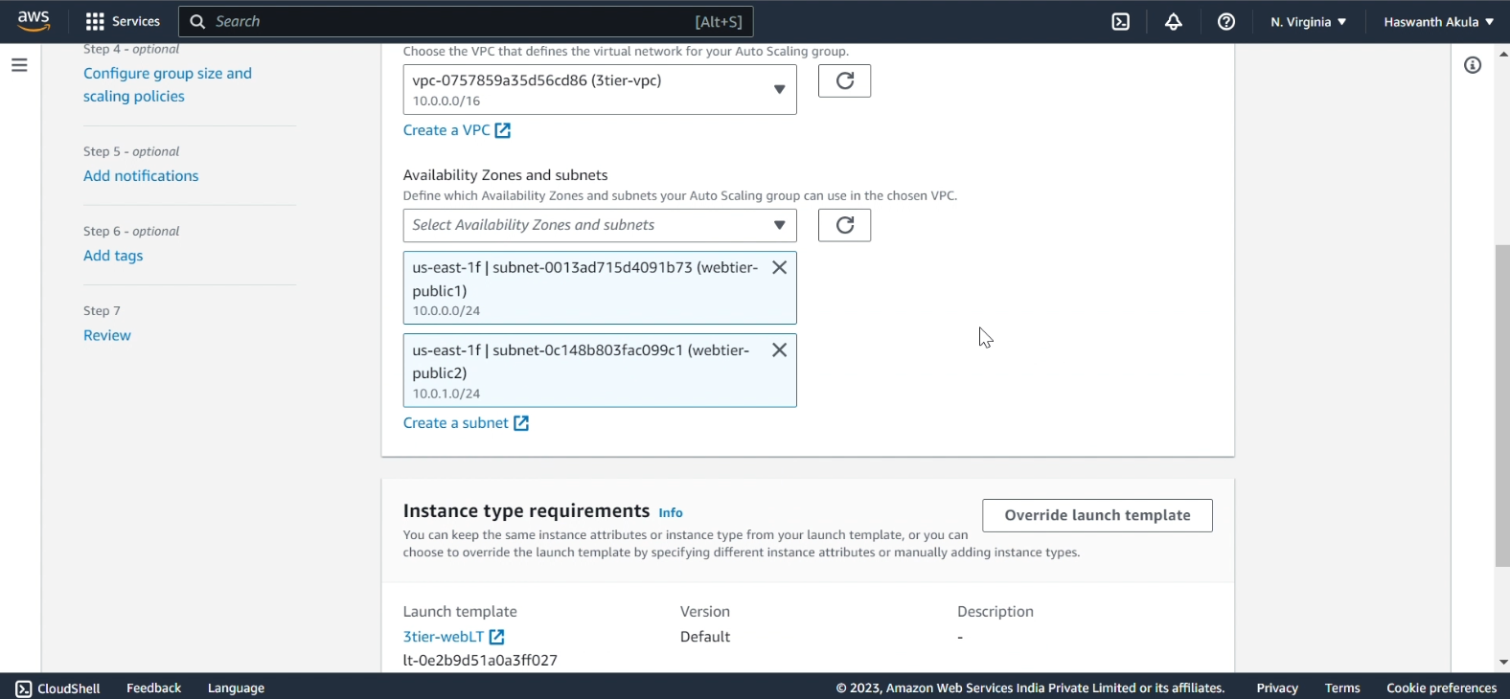

Then Click Next, Next.... leave all default; Then Create AutoScallingGroup.

Auto Scaling group for your Web Tier is created.

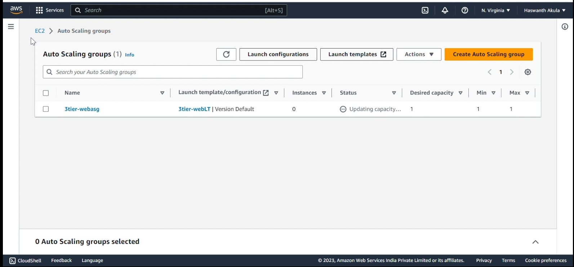

Go to the Ec2 dashboard there is a Instance Spin by ASG Running there:

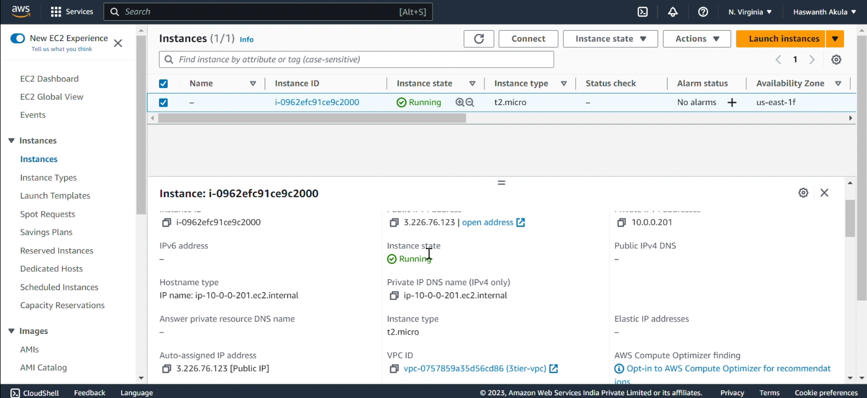

Furthermore, if you go to your webtier Ec2, copy the DNS name, and paste it into your browser, you will also be able to access your website.

Congratulations on successfully building the Web Tier!

**Step 3: Create the Application Tier**

In the Application Tier, we will create another Auto Scaling Group (ASG) to launch EC2 instances in two private subnets. These instances will be configured to allow inbound traffic access from the Web Tier.

Similar to the steps followed in the Web Tier, go to your EC2 dashboard and scroll down. On the left side, click on “Auto Scaling Groups” and then select “Create Auto Scaling group”.

Provide a name for your Auto Scaling Group and then click on “Create a launch template”. For the launch template configuration, select the same Amazon Machine Image (AMI), such as Amazon Linux 2, and instance type (t2.micro) that were used in the previous launch template. Finally, choose a key pair for secure access to the instances.

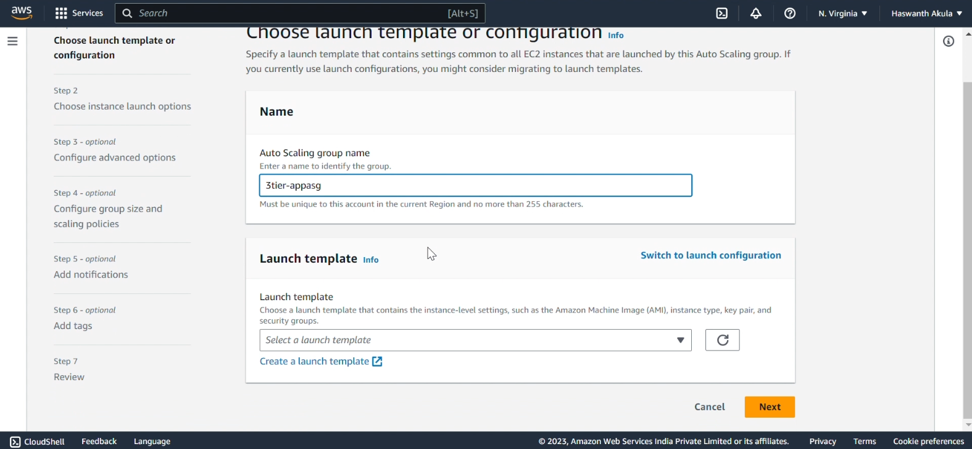

Now that we have completed the configuration of our Application Tier launch template, we can proceed by clicking on “Create launch template”.

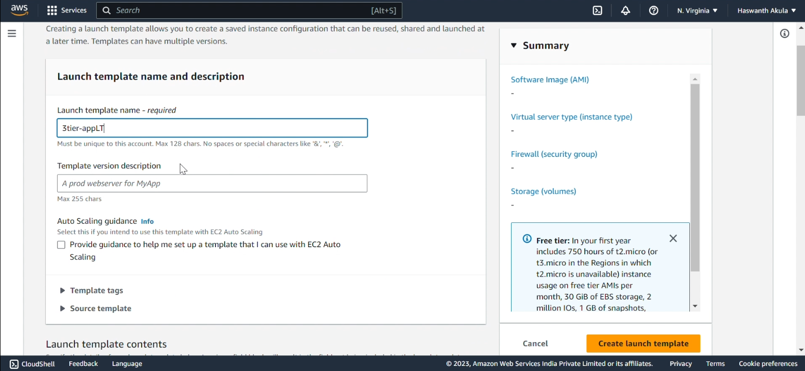

Next, navigate to the “Network setting” section and create a new security group. Select your VPC, and then configure the security group rules accordingly. Allow SSH access from the Web Tier security group.

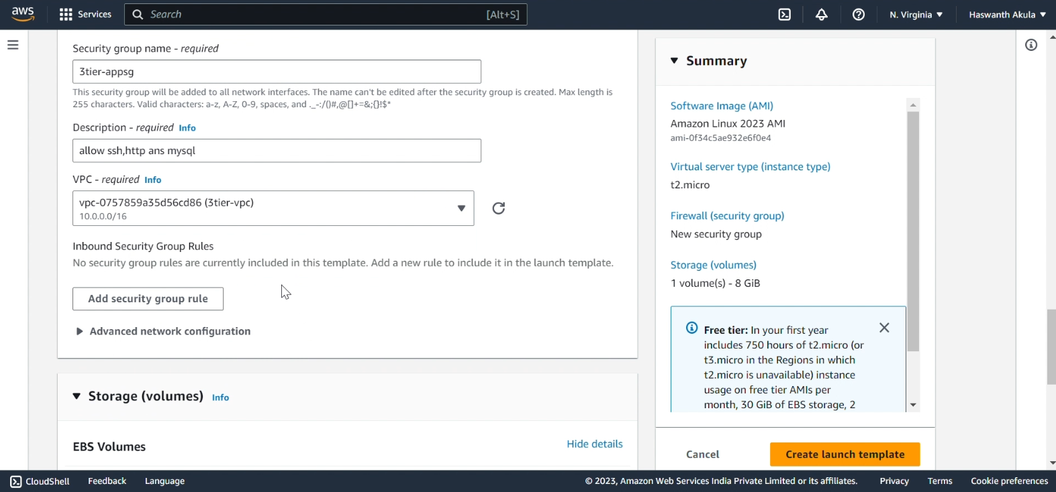

Return to the Application Tier ASG configuration and choose the recently created launch template for the setup and go next step.

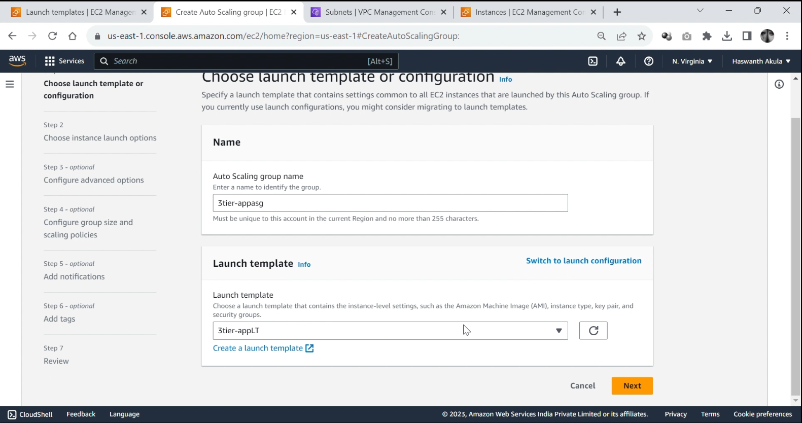

Select your Virtual Private Cloud (VPC) and then choose the two private Availability Zones (AZs) within your network that will host the EC2 instances for the Application Tier. Once you have made the selections, click on “Next”.

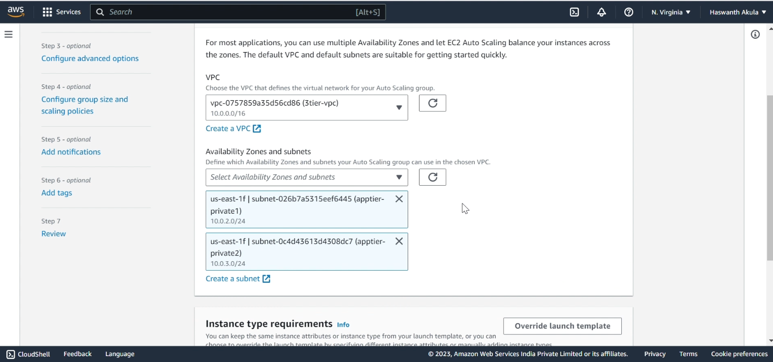

Click on “Next.” Optionally, you can add notifications and tags as per your preference. Review all the settings and configurations, ensuring they are accurate. Finally, click on “Create Auto Scaling group” to proceed and create the Application Tier Auto Scaling group.

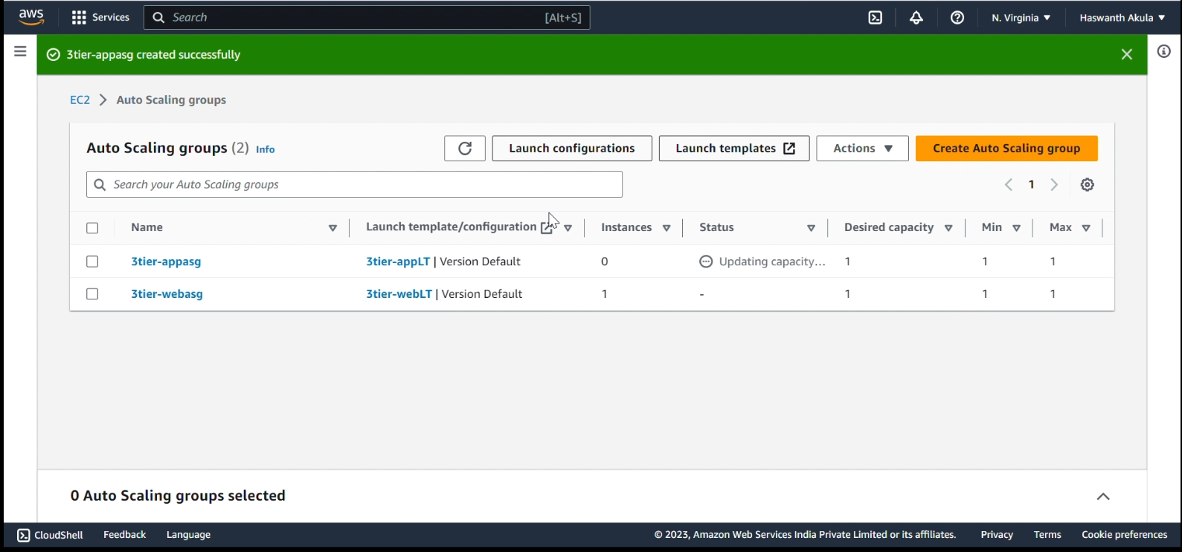

Our new Application Tier ASG should be created.

Go to the Ec2 dashboard there is a Instance Spin by ASG Running there:

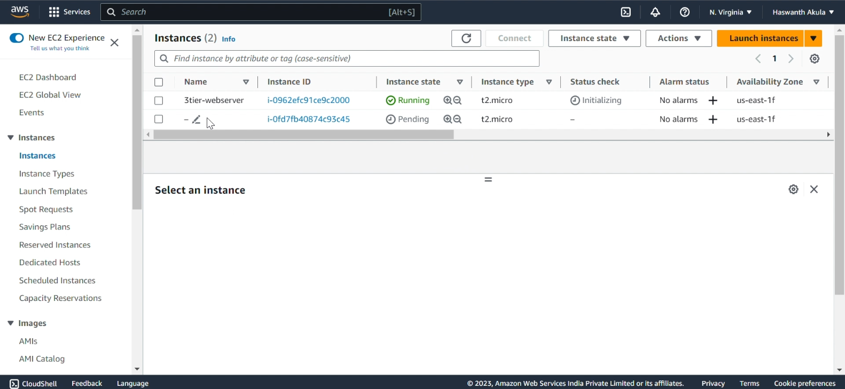

There is No Public Ip to connect because it is a AppTierEC2 it is in Private Subnet.

We connect to it through remote by WebTierEC2.

Remote to PublicInstance(webserver) to PrivateInstance(appserver):-

Create a file by command: $nano appkey

Write some text in the file. (Paste filename.pem Content)

Press Ctrl+O to save the file.

Type the name of the file, and then press Enter.

Press Ctrl+X to exit nano.

$ chmod 400 appkey

$ ssh -i appkey ec2-user@PrivateIp of AppTierEC2

Check internet is there: $ ping 8.8.8.8

We have Internet, we get through NAT Gateway

Launch Templates Launched:

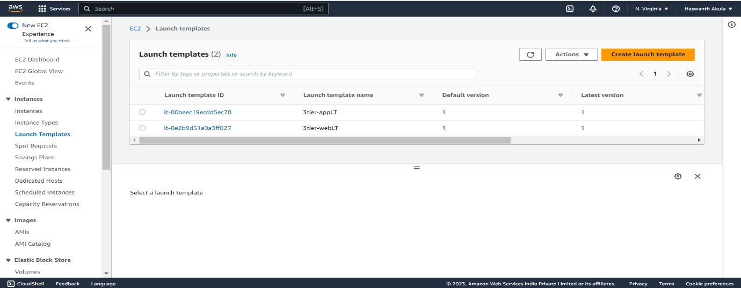

Auto Scaling Groups Launched:

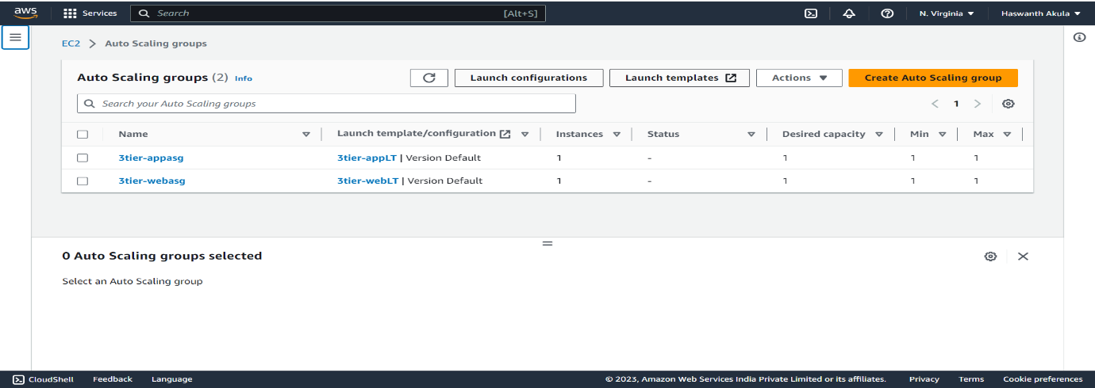

Instances Launched:

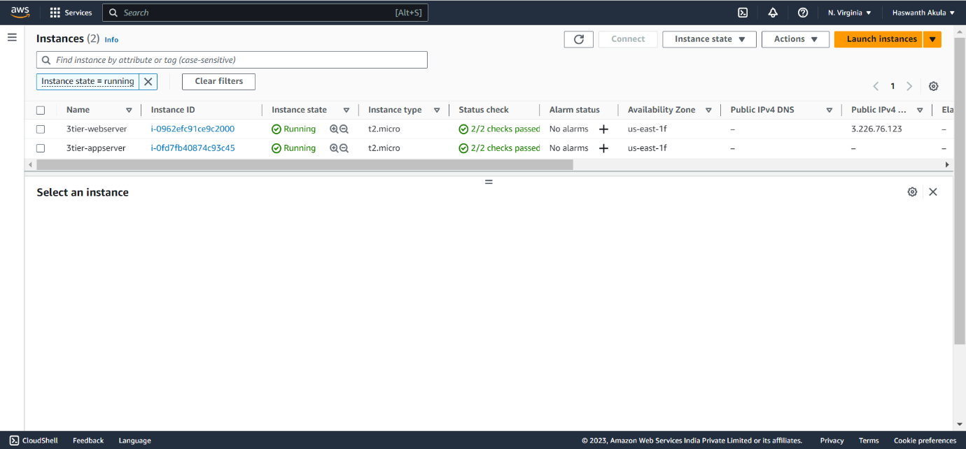

**Step 4: Creating a Database Tier**

We will set up a MySQL database within the private subnets specifically for the Application Tier. The Application Tier will be able to establish connections and interact with this database.

To ensure higher availability and data redundancy, you can choose for a Multi-AZ DB Instance deployment. Create the subnet group with these selections to establish the Multi-AZ configuration.

Navigate to RDS and click on “ Create databases”then Select “Standard create” and “MySQL.”

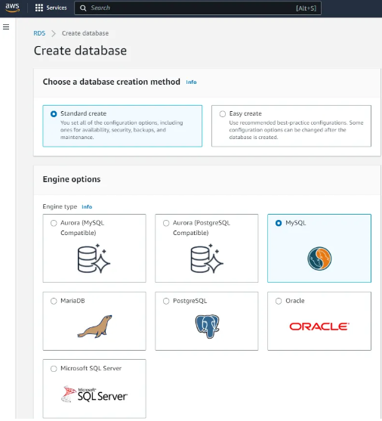

We will be using the free tier template for the database deployment.

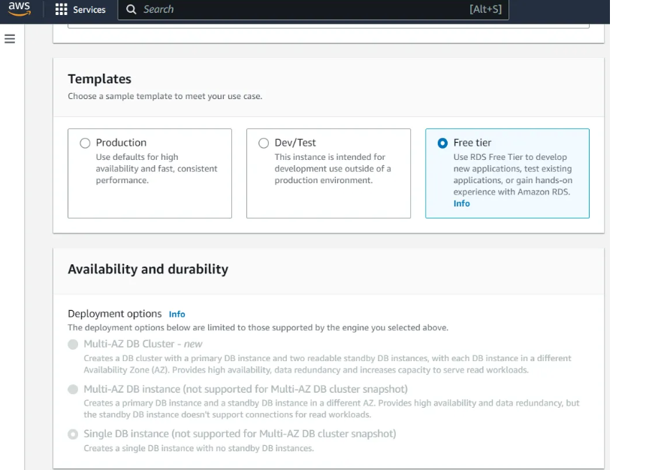

In the Settings section, provide a name for the DB instance. Additionally, create a unique master username and password for the database. It is important to note that this username and password should be distinct from your AWS account user login credentials, as they are specific to the database you are creating.

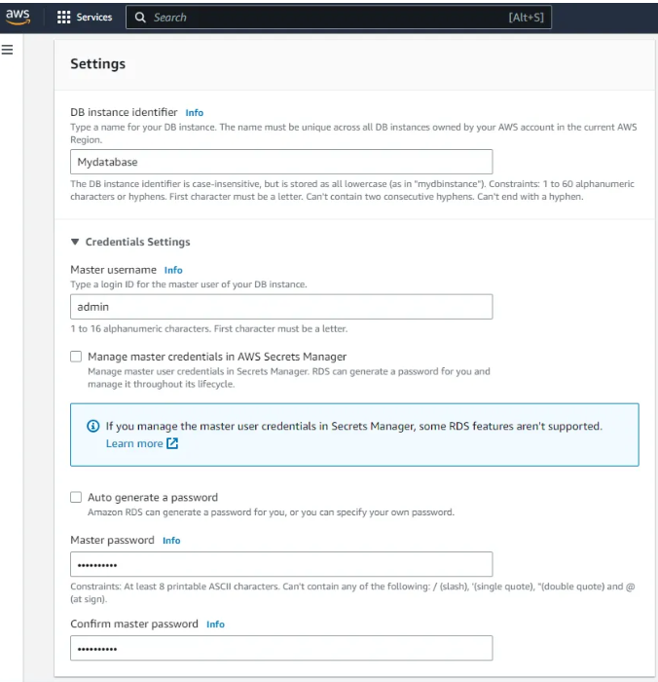

Proceed to the “Connectivity” section and select your VPC and the DB subnet group that you created earlier. Ensure that “Public access” is set to “No” since the database will only be accessed privately through the Application Tier. Choose “Create new” for the security group and provide a name for it.

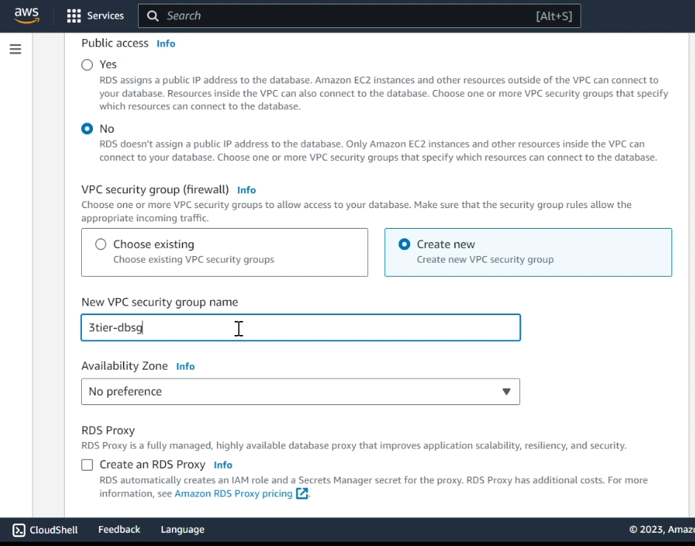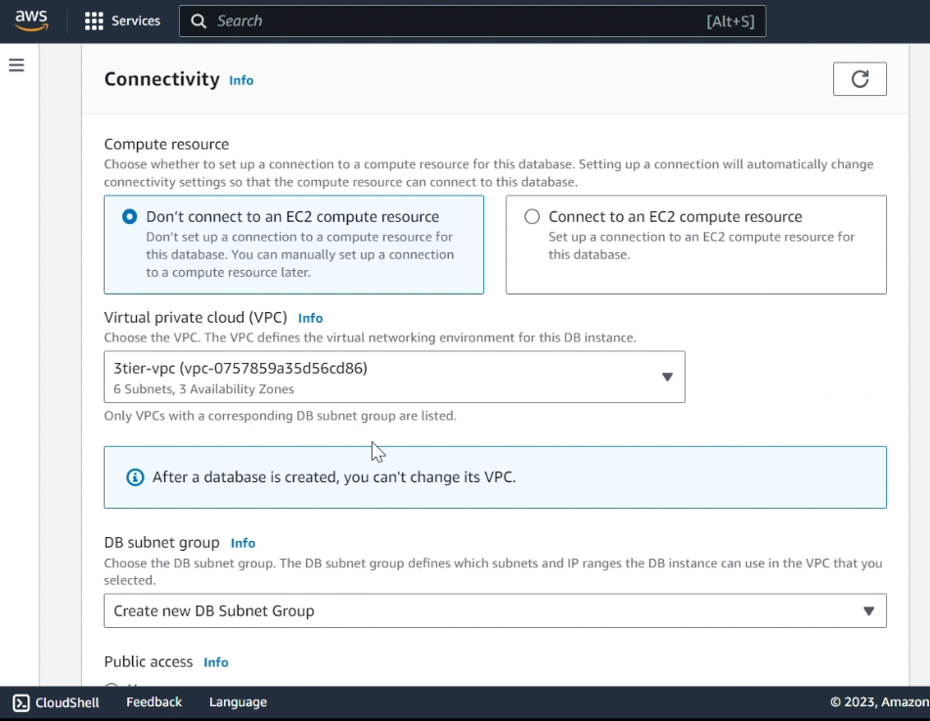

In the Database authentication section, you have three options to choose from. Additionally, you have the option to enable enhanced monitoring and configure additional settings if required. Once you have made all the necessary selections and configurations, click the “Create database” button to initiate the database creation process.

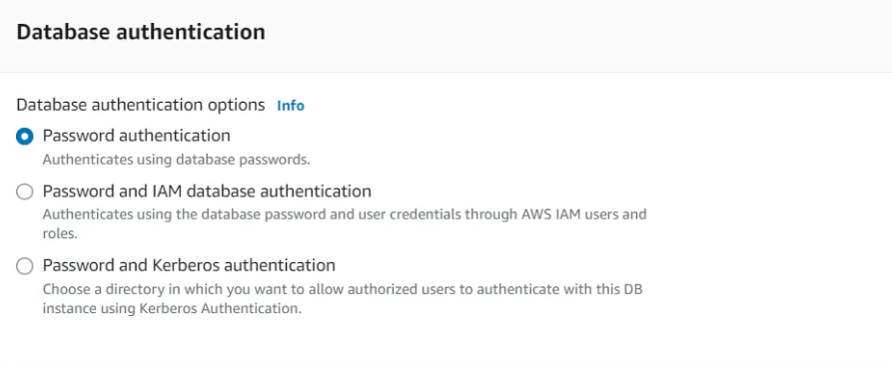

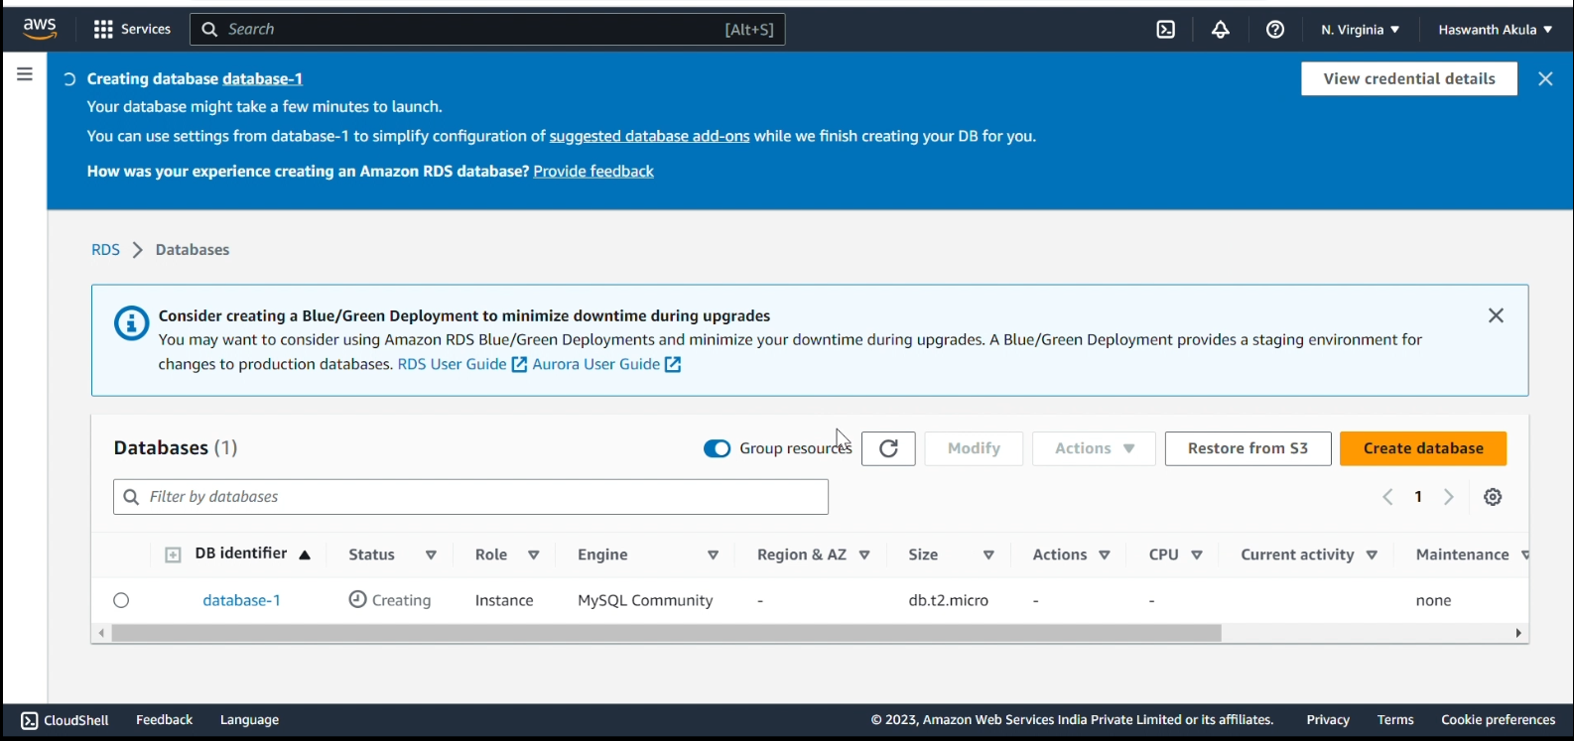

Select your new Database, then in the “Connectivity & security tab”, click the security group to edit it.Click on “Edit inbound rules” on the bottom right, then delete the database security group has an inbound rule to allow MySQL/Aurora traffic on port 3306 from your IP address.

We all new rule to allow inbound traffic for MySQL from the application tier security group instead. Click “Add rule,” select “MySQL/Aurora” for Type (this will insert port 3306), choose custom Source, and then select your application tier security group and “Save rules.”

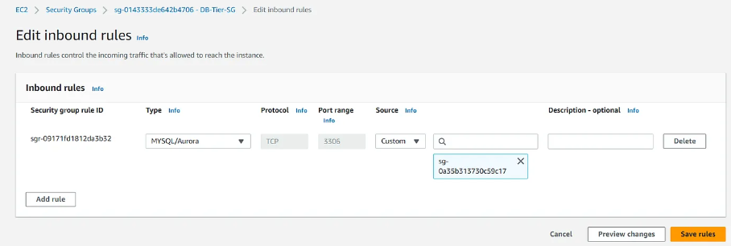

Now we access the DataBase through AppTier.

Commands:

Install MySQL

sudo wget http://dev.mysql.com/get/mysql57-community-release-el7-8.noarch.rpm

sudo yum localinstall mysql57-community-release-el7-8.noarch.rpm

sudo yum install mysql-community-server

Connect to Database(mysql):

mysql -h DATABASE_ENDPOINT -u USERNAME -p

**We successfully constructing a 3-Tier Architecture AWS cloud infrastructure through the Management Console!**